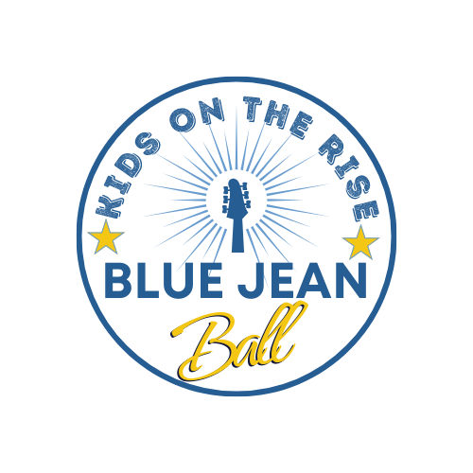

June 14, 2025
 |  |  |  | Gold | Silver | Bronze | Partner | Table Sponsor
 |  |  |  | $1,000 or more | $500 | $250 | $100 | $360
Name on all Event Promotions |  |  |  | X
Banner Display/Company Name and Logo |  |  |  | X | X | X
Event Tickets |  |  |  | Up to 8 | 2 | 0 | 0 | 8
Name on Table |  |  |  | X |  |  |  | X
Name in Event Program |  |  |  | X | X | X | X | X
Ad in program |  |  |  | Full page | Half page | Quarter page
KOTR Social Media: Website and Facebook |  |  |  | X | X | X

Kids On The Rise is a nonprofit agency (EIN 34-1974412) whose mission is to provide experiences for youth that will enable them to further develop their intellectual, social, verbal, and creative capacities and to facilitate their entry into a responsible, productive adulthood. Our primary method for achieving our mission is through a mentoring program for children and youth.
Our annual fundraising event, the Blue Jean Ball, will be held June 14, 2025. The Blue Jean Ball is a casual event with live music, dinner, and a silent and live auction. The event will be held at the Barn at Oaklawn Farms. In the past, we have averaged around 300 in attendance each year and raised approximately $75,000 for our programs.
We would love to partner with you to help make this event a success and continue helping kids in Cumberland County reach their full potential.
Sincerely,
Pam Burris
Executive Director

